

**ACTIVITY REPORT**

**ON DUO’S DASH 3.0**

1. **Name of the Club:** BMSCE ACM STUDENT CHAPTER
2. **Name of the Activity:** Duo’s Dash 3.0
3. **Objectives:** The BMSCE ACM Student Chapter organized Duo’s Dash 3.0 on account of UTSAV’25. We aim to strengthen connections and forge new bonds during this event. Most of all, we wanted to ensure that our participants have a wonderful experience at UTSAV’25 while playing our mini-games.
4. **Date, Time Venue of the Activity:**

| **EVENT** | Duo’s Dash 3.0 |
| --- | --- |
| **DATE/DAY** | Saturday, 10th May 2025 |
| **TIME** | 9:00 am to 4:30 pm |
| **VENUE** | 2nd Floor Common Area, PJA Block |

1. **Name and details of collaborating agency (if it is collaborative/joint activity):** None
2. **Brief summary of the Event:**

Duos Dash 3.0, organized by the BMSCE ACM Student Chapter during UTSAV 2025, the annual cultural fest of BMS College of Engineering, was a fast-paced and fun-filled event made for teams of two. The event had four unique rounds, each testing different skills like teamwork, creativity, and quick thinking. The first round, Bomb Diffusion, took place in Roblox, where one teammate gave instructions while the other worked to diffuse a virtual bomb. This round was all about communication and trust. In the second round, Fliptionary, one teammate drew in the air using a flipped screen, while the other had to guess the word—leading to lots of laughs and surprises. The third round, Movie Charades, had one teammate give a prompt to Google Gemini AI, and the other guessed the movie based on the AI-generated image. The final round, Draw & Dare, used UNO cards to assign fun tasks. Each team had three chances to draw a card and complete a dare based on its color, earning points as they went. Duos Dash 3.0 brought together tech, creativity, and teamwork in a fun and memorable way. It truly matched the energy and excitement of UTSAV 2025.

1. **Outcomes:**

All the participants left the event with a feeling of accomplishment after playing the games. They were all highly anticipating the results. These games fostered a sense of connection and strengthened the bond present between two friends. It also strengthened the teamwork and initiative of the BMSCE ACM Student Chapter beyond technical activities since we learnt what it is like to function as a group and complete our tasks.

**Number of participants:**

| **Number of Registrations** | **Number of teams that played** |
| --- | --- |
| 46 | 43 |

1. **Photographs of the event:**

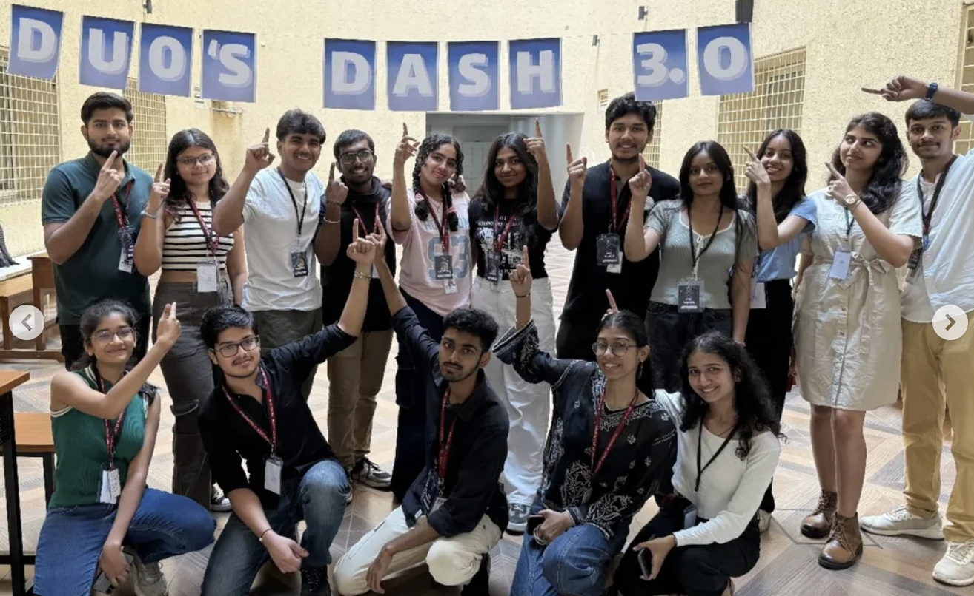

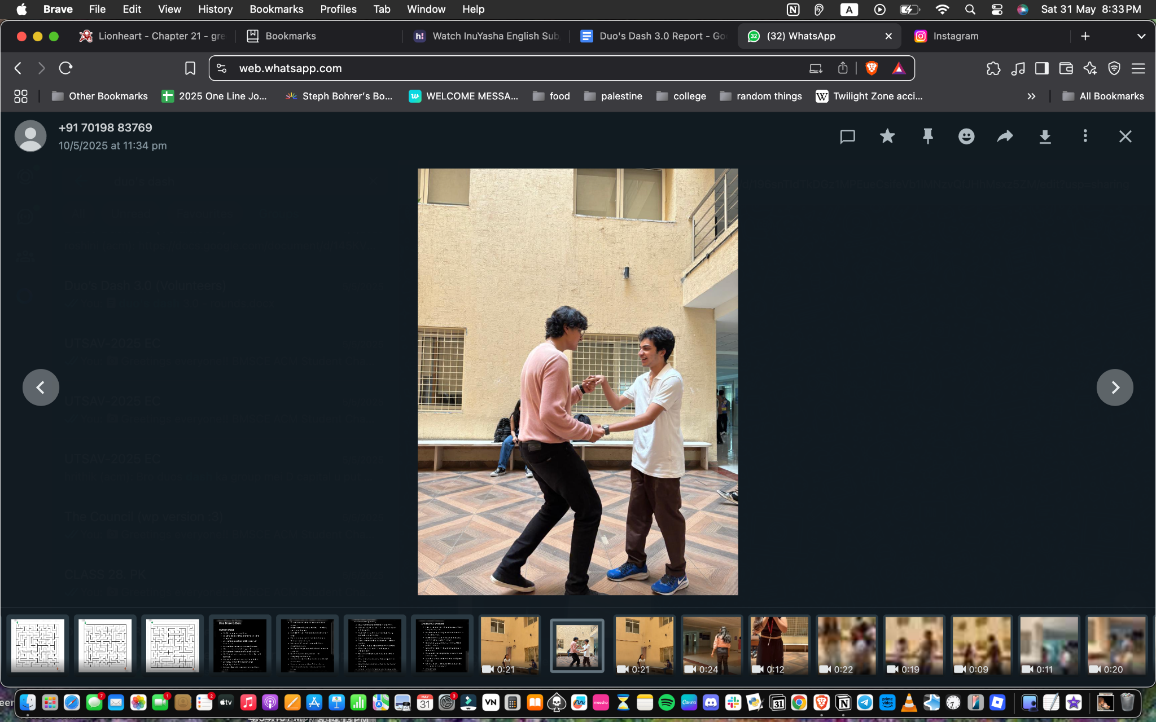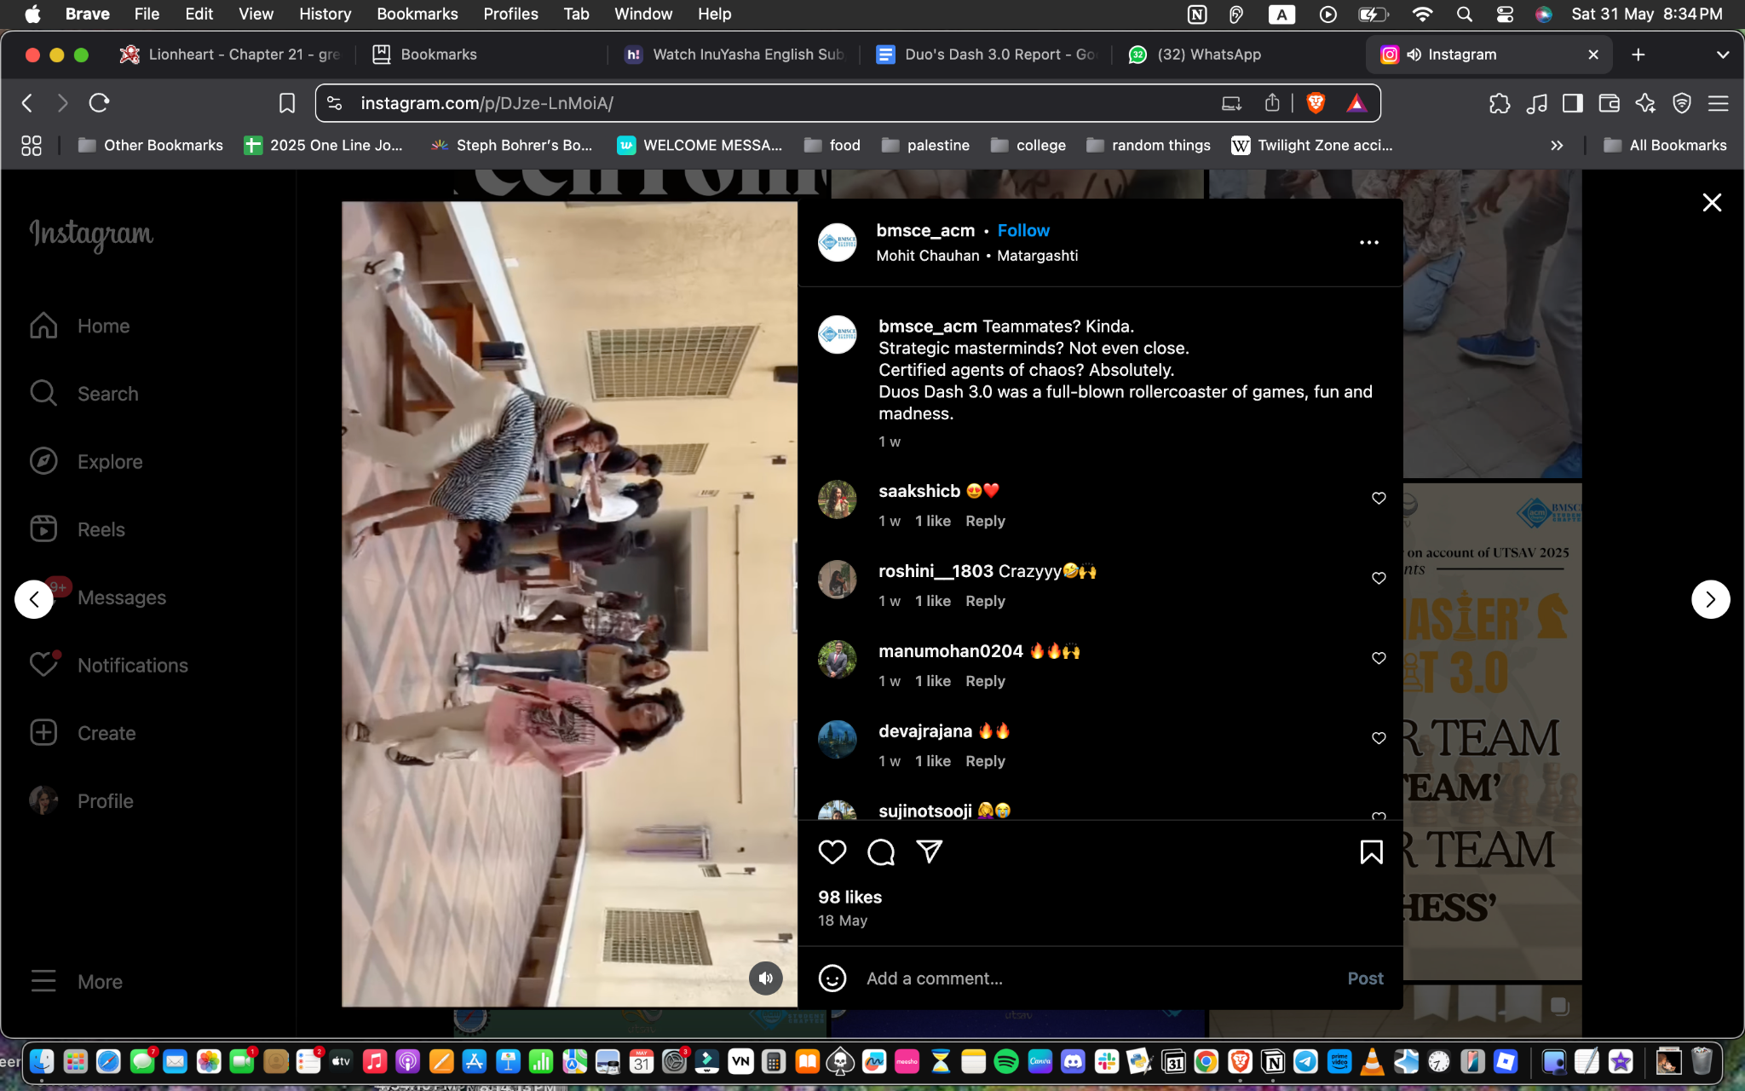

1. **Supporting Documents:**

**a.** **Circulars/Brochures:**

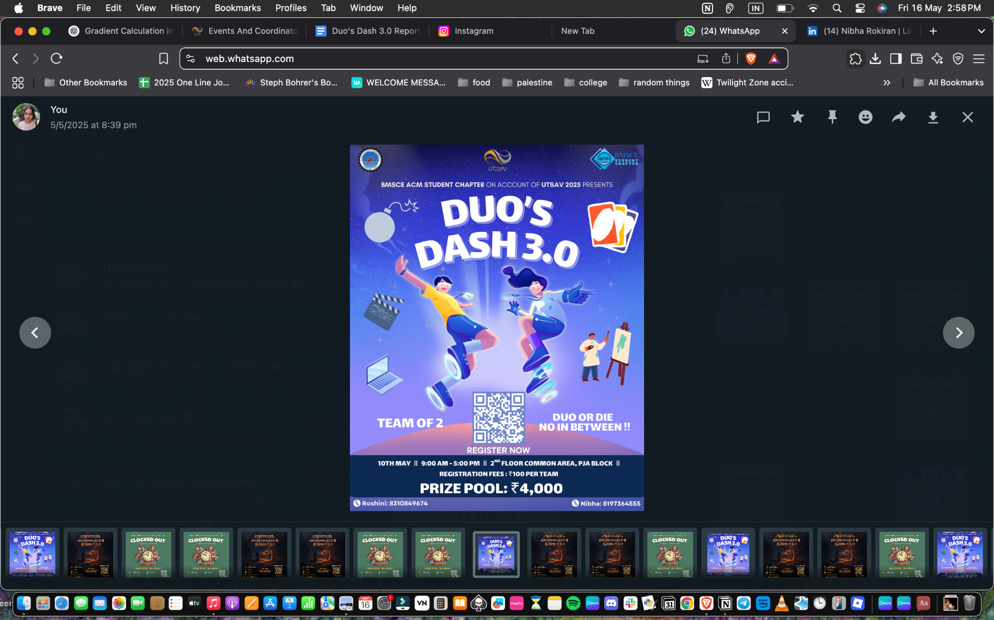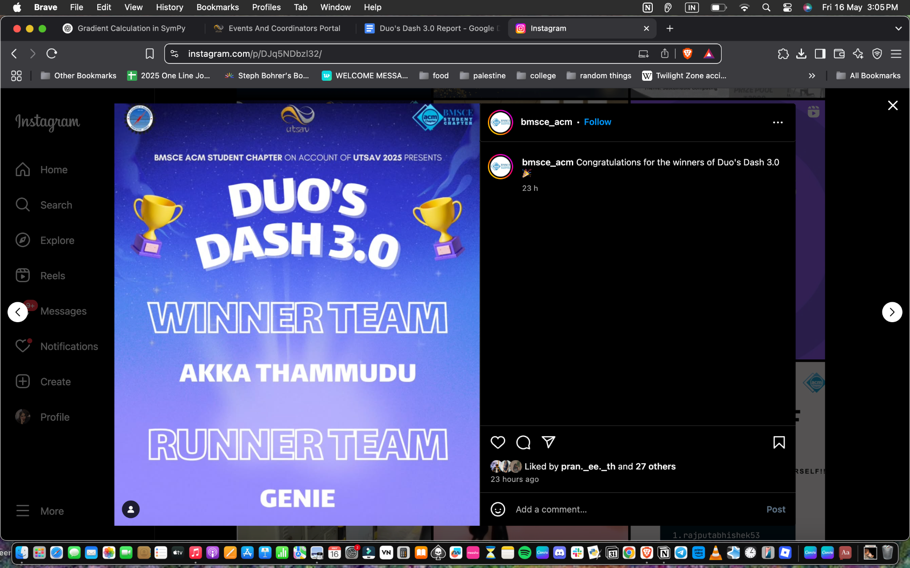

**b.** **Attendance:**

| Hitaishi G | hitaishii2005@gmail.com | Sanchana TS | sanchanats.cs24@bmsce.ac.in |
| --- | --- | --- | --- |
| Rizwana | rizwana.ad23@bmsce.ac.in | Tanisha Shinthray | tanishashinthray.ad23@bmsce.ac.in |
| Vaibhav Reddy | mvaibhav.ai24@bmsce.ac.in | Haratejas N | haratejas.ai24@bmsce.ac.in |
| Harshini P R | harshinipr.cs24@bmsce.ac.in | Gayatri Shekhar J | gayatrishekhar.cs24@bmsce.ac.in |
| Adwika Vishal | adwikavishal.cs24@bmsce.ac.in | Allu Saatvika | allusaatvika.cs24@bmsce.ac.in |
| varsha bhat | varshabhat.ai24@bmsce.ac.in | Kashvi | kashvin.cvs24@bmsce.ac.in |
| Bommireddy Neha | bommireddy.cd22@bmsce.ac.in | G Sri Sai Meghana | saimeghana.cd22@bmsce.ac.in |
| Rudra Pratap | rudrapratap.cs24@bmsce.ac.in | rishi s | rishis.cs24@bmsce.ac.in |
| Rushikesh Rangappa | rushikesh.cs24@bmsce.ac.in | rohan raghu prasad | rohanraghu.cs24@bmsce.ac.in |
| H Samarth Prabhu | hsamarth.ec24@bmsce.ac.in | dhanvi bhat | dhanvibhat.ec24@bmsce.ac.in |
| Mridhvik reddy | mridhvikreddy.ai24@bmsce.ac.in | neehar rajeev krishnan | neeharquiz@gmail.com |
| Naga Brunda | nagabrunda.ai24@bmsce.ac.in | malyala sonika | malyalasonika.ai24@bmsce.ac.in |
| Kaustubh Rao Kandula | krkistheonlyone@gmail.com | Anaghashri S | anaghashri5@gmail.com |
| Yuvraj | yuvraj05828@gmail.com | Sai Teja | saiteja99722@gmail.com |
| Ananya Bhat | ananyabhat.ec23@bmsce.ac.in | Avishka Arun | avishkaarun.ec23@bmsce.ac.in |
| Mohammed Fahim | mohammedfahim.ai24@bmsce.ac.in | mukund gopinath | mukundgopinath.ai24@gmail.com |
| Angelina Shukla | angelina.cd24@bmsce.ac.in | Sandhi Reddy Siri | sandhireddy.cd24@bmsce.ac.in |
| Harshitha U S | harshithaus.ec24@bmsce.ac.in | Shreshta Chiranjeevi BK | shreshta.ec24@bmsce.ac.in |
| Samrudhps | samrudhps.cs24@bmsce.ac.in | Anirudha S J | anirudhashriyak.cs24@bmsce.ac.in |
| Rekulakunta Sravanthi | sravanthi.cs24@bmsce.ac.in | Paleti Grishma Sree | grishmasree.ai24@bmsce.ac.in |
| Srujana A Rao | srujana.cd22@bmsce.ac.in | Gaurvaditya Singh | gaurvaditya.cd22@bmsce.ac.in |
| Harihara vardhan K | hariharavardhan.is23@bmsce.ac.in | Dhruv H | dhruvh.is23@bmsce.ac.in |
| Kruthi Guduru | gudurukruthi.cs24@bmsce.ac.in | hithaishi p | hithaiship.cs24@bmsce.ac.in |
| Ridhi | ridhiganesh.cs24@bmsce.ac.in | ayush | gpayush7225@gmail.com |
| Naysha Shrivastava | nayshanavin.cs24@bmsce.ac.in | Sai Keerthana | saikeerthana.cs24@bmsce.ac.in |
| Hardik Jain | hardikjain.ec24@bmsce.ac.in | Neyati | neyati.ci24@bmsce.ac.in |
| Tanisha | mohantytanisha3@gmail.com | Parthavi R | prathavir.ci23@bmsce.ac.in |
| Kritarth | kritarthteli.cs24@bmsce.ac.in | Navya | navyaagrawal.cs24@bmsce.ac.in |
| Vimarsha Hegde | vimarshahegde18@gmail.com | rishika kumarswamy | rishikak2006@gmail.com |
| BARUNI | barunigangadhara.cs24@bmsce.ac.in | ashrita | ashritaanand.ec24@bmsce.ec.in |
| kashvith | kashvithd@gmail.com | prachi | prachi.a.madihalli@gmail.com |
| devaj | devajrajana@gmail.com | tejeswara | tejeswararaju.ai24@bmsce.ac.in |
| abhay | abhayny.cs24@bmsce.ac.in | disha | dishaa.is24@rvce.edu.in |
| jatin | jatinagarwal.cs24@bmsce.ac.in | Parth verma | parthverma.ec24@bmsce.ac.in |
| hardik swami | hardikswami.se24@bmsce.ac.in | shrish roy | shrishroy.cs24@bmsce.ac.in |
| suchit | suchitsm.ad24@bmsce.ac.in | jyeshta | jyeshtashetty.ad24@bmsce.ac.in |
| rakshit | rakshitanand.cs24@bmsce.ac.in | sohaan gaba | sohaangaba.cs24@bmsce.ac.in |
| bhoomika | bhoomikahi01@gmail.com | mythri | mythrip.000@gmail.com |
| dhruv | dhruvkumar.cs24@bmsce.ac.in | dipto | diptopaul.cs24@bmsce.ac.in |
| harshavardhan s | harshavardhan.cd22@bmsce.ac.in | pavithra g | pavithra.cd22@bmsce.ac.in |
| krishay | krishaymanjunath@gmail.com | supreet | supreet.bhat1234@gmail.com |
| vynik | vynikjain@gmail.com | yashas | yashbol1234@gmail.com |
| G. Sri Sai Meghana | saimeghana.cd22@bmsce.ac.in | devaj | devajrajana@gmail.com |